INNOVA JUNIOR COLLEGE
JC 2 PRELIMINARY EXAMINATION (2010)
Higher 2 CHEMISTRY

Paper 1 Answers

1 | A | 11 | B | 21 | B | 31 | C
2 | A | 12 | D | 22 | A | 32 | C
3 | D | 13 | B | 23 | C | 33 | C
4 | A | 14 | A | 24 | C | 34 | A
5 | B | 15 | D | 25 | C | 35 | A
6 | B | 16 | C | 26 | A | 36 | B
7 | B | 17 | D | 27 | C | 37 | D
8 | B | 18 | B | 28 | B | 38 | C
9 | D | 19 | C | 29 | C | 39 | B
10 | B | 20 | C | 30 | A | 40 | A

Paper 2 Answers

1(a) |  | - Use known mass of sample  - & dissolve in dilute sulfuric acid to make 250 cm³ solution using a 250 cm³ standard flask  - Pipette (25 cm³ or 20 cm³) portions of the above into a 250 cm³ conical flask & acidify with dilute sulfuric acid.  - Titrate with (known concentration) of KMnO₄ in a burette  OR  - Weigh known mass of sample  - Dissolve the powder in aqueous H₂SO₄ of known concentration.  - Transfer the resultant solution into a 250 cm³ standard flask and top up with distilled water. Shake well.  - Pipette 25.0 cm³ of the solution into a conical flask and add a few drops of ferroin indicator.  - Titrate the solution with standard solution of potassium dichromate (VI) from the burette until the indicator turns from red to blue.  - Note the volume of potassium dichromate (VI) used.  - Repeat the experiment until consistent values for potassium dichromate (VI) are obtained.
(b)(i) |  | MnO₄⁻ (aq) + 5Fe²⁺ (aq) + 8H⁺ (aq) → 5Fe³⁺ (aq) + Mn²⁺ (aq) + 4H₂O (l)
(b)(ii) |  | 3OH⁻ (aq) + Fe³⁺ (aq) → Fe(OH)₃ (s)  2OH⁻ (aq) + Mn²⁺ (aq) → Mn(OH)₂(s)
(iii) |  | Iron(II) ions will form precipitate of iron(II) hydroxide / react with aq NaOH, thus it’s not possible/ not a suitable method to use NaOH(aq) to determine value of x.
(c) |  | Test :  Step 1: add BaCl₂ / Ba(NO₃)₂ to the solution sample  Step 2: add dilute HCl / HNO₃ to the ppt.  Observation:  For SO₄²⁻ : white ppt insoluble in excess dilute acids  For SO₃²⁻: white ppt dissolve in excess dilute acids & SO₂ gas evolved that turn green with orange dichromate.
2 | (a) |  | (i) | K_{sp} = [Mg²⁺][CO₃²⁻]  If student only identify the salt, MgCO₃
 |  |  | (ii) | MgCO₃ (s) Mg²⁺ (aq) + CO₃²⁻ (aq)  x x  K_{sp} = x²  x = √(6.82 x 10⁻⁶)  = 2.61 mol dm⁻³
 |  |  | (iii) | Concentration of the compounds will halved when equal volumes are mixed.  [Mg²⁺] = 0.0100/2 = 0.005 moldm⁻³  [Sr²⁺] = 0.0100/2 = 0.005 moldm⁻³ for both cations  [CO₃²⁻] = 5 x 10⁻⁴ /2 = 2.5 x 10⁻⁴ moldm⁻³  IP of MgCO₃ = [Mg²⁺][CO₃²⁻]  = 0.005 x 2.5 x 10⁻⁴  = 1.25 x 10⁻⁶ mol²dm⁻⁶ (<K_{sp}, no precipitation occurs)  Units for K_{sp} not marked for.  IP of SrCO₃ = [Sr²⁺][CO₃²⁻]  = 0.005 x 2.5 x 10⁻⁴  = 1.25 x 10⁻⁶ mol²dm⁻⁶ (>K_{sp}, precipitation occurs)  Units for K_{sp} not marked for.  White precipitate of SrCO₃ will be observed.
 | (b) |  | (i) | FeCO₃ will decompose at a temperature higher than 250°C.  The cationic size of Mg²⁺ is 0.065nm and Fe²⁺ is 0.076nm. As Fe²⁺ has a bigger cationic size and a smaller charge density, it will polarise CO₃²⁻ to a smaller extent and more heat needs to be supply to decompose it, hence higher decomposition temperature.
 |  |  | (ii) | 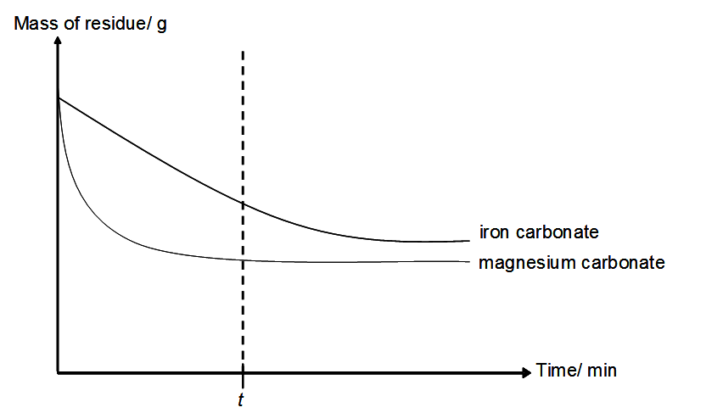
 |  |  |  | Figure 1
 |  |  |  | [4]
 | (c) |  | (i) | 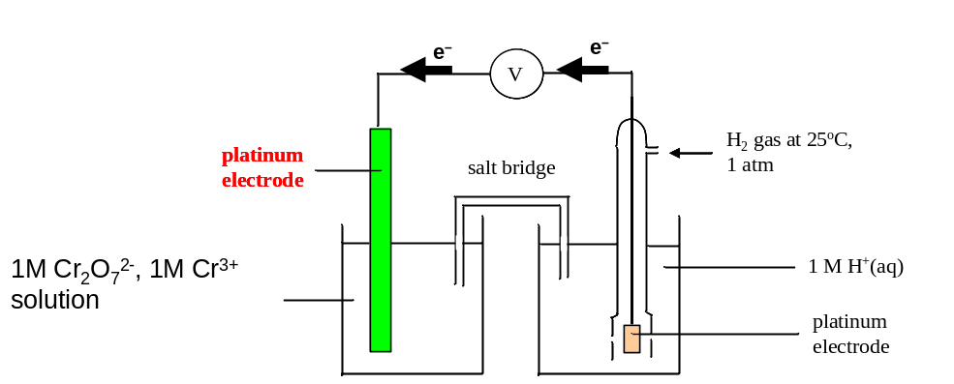
 |  |  | (ii) | By considering E^{θ} values, suggest one possible reaction that will occur when aqueous acidified Na₂Cr₂O₇ is added to VOSO₄.
Cr₂O₇²⁻ + 14H⁺ + 6e 2Cr³⁺ + 7H₂O E^{θ} = +1.33V
VO₃⁻ + 4H⁺ + e VO²⁺ + 2H₂O E^{θ} = +1.00V
E^{θ}_{cell} = E^{θ} _{red} - E^{θ}_{oxid}
= +1.33- (+1.00) choose half equation correctly
= +0.33V
Cr₂O₇²⁻ + 5H₂O+ 6VO²⁺→ 6VO₃⁻ + 2Cr³⁺ + 10H⁺

OR

Cr₂O₇²⁻ + 14H⁺ + 6e 2Cr³⁺ + 7H₂O E^{θ} = +1.33V
VO₂⁺ + 2H⁺ + e VO²⁺ + H₂O E^{θ} = +1.00V

E^{θ}_{cell} = E^{θ} _{red} - E^{θ}_{oxid}
= +1.33- (+1.00) choose half equation correctly
= +0.33V

Cr₂O₇²⁻ +6VO²⁺ +2H⁺→ 6VO₂⁺ + 2Cr³⁺ + H₂O

3 | (a) | 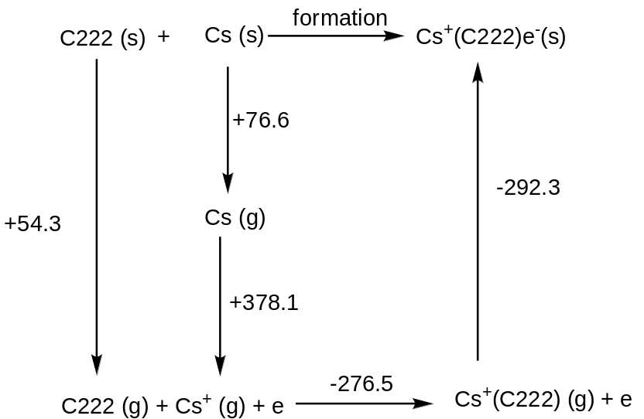  Enthalpy change of formation = +54.3 +76.6 + 378.1 -276.5 -292.3  = -59.8 kJ mol⁻¹
 | (b) | (i) | Denaturation is the disruption of the shape of protein without changing its primary structure but results in loss of biological activity OR the secondary and tertiary structures are disrupted.
 |  | (ii) | Side chain of S is affected by changes in pH.  At high pH : -COOH + OH⁻ à -COO⁻ + H₂O  At low pH : -COO⁻ + H⁺ à -COOH  OR  Side chain of T is affected by changes in pH.  At high pH: -NH₃⁺ + OH⁻ à -NH₂ + H₂O  At low pH : -NH₂ + H⁺ à -NH₃⁺
 | (c) | (i) | N¹ is more basic.  This is because the alkyl group increases the electron density on the N¹ atom, making the lone pair of electrons more available to accept a proton.  OR  It also stabilizes the conjugate acid by dispersing the positive charge on the conjugate acid making it more stable than the RN²H₃⁺ ion.  OR  Lone pair of electrons on N² atom is delocalised into the π electron cloud of benzene ring, making the lone pair of electrons less available to accept a proton.  OR  The aromatic group intensifies the positive charge on the conjugate acid making it less stable than the RN¹(C₂H₅)₂H⁺ ion.
 |  | (ii)
  Reagents | Organic Products
  hot aqueous HCl | 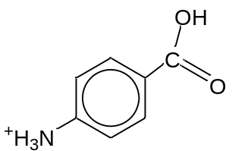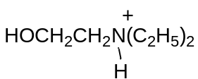
  aqueous Br₂ in the dark | 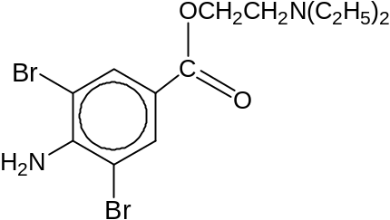

4 | (a) | (i) | 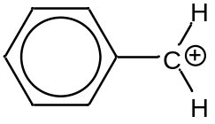
 |  | (ii) | The intermediate in (a)(i) can be resonance stabilized while the cation formed from C₆H₅CH₂CH₂Cl cannot be resonance stabilized because the carbocation and the benzene ring has an sp³ carbon in between them which makes resonance stabilization impossible .
 | (b) | Mechanism : Electrophilic substitution  Generation of electrophile :  HNO₃ + H₂SO₄ → H₂NO₃⁺ + HSO₄⁻  H₂NO₃⁺ → NO₂⁺ + H₂O  OR H₂SO₄ + HNO₃ 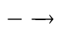 NO₂⁺ + HSO₄⁻ + H₂O  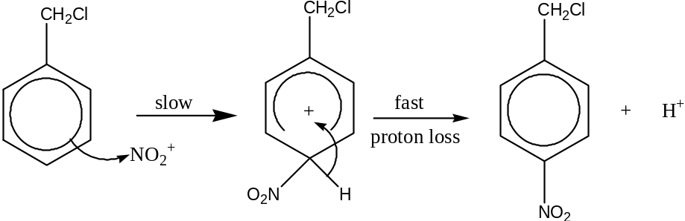  The H⁺ formed regenerates a molecule of H₂SO₄.  H⁺ + HSO₄⁻ → H₂SO₄
 | (c) | (i) | pH = pKa + log 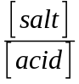  5.00 = -log(6.3 x 10⁻⁵) + log 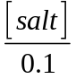  5.00 = 4.200 + log  log = 0.8  = 10^{0.8} = 6.3095  [salt] = 0.63096 mol dm⁻³  = 0.63096 x 144.0  = 90.858 g dm⁻³  = 90.9 g dm⁻³
 |  | (ii) | Dissolve (90.858 ÷ 2)  = 45.429  = 45.4 g of sodium benzoate  in 500 cm³ of 0.1 mol dm⁻³ aqueous benzoic acid.
(d) | 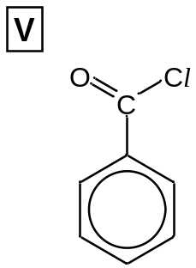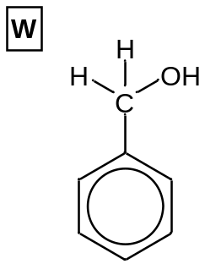  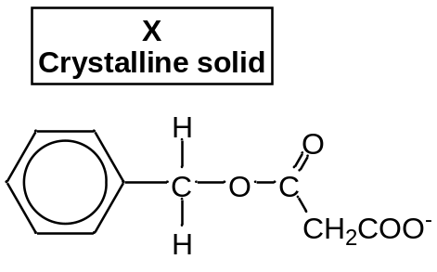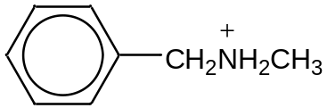  Step I :  Reagent : PCl₅  Condition : Room temperature  Step II :  Reagent : LiAlH₄  Condition : Dry ether
5 | (a) | (i) | Initial rate when [NaOH] = 0.200 mol dm⁻³  = 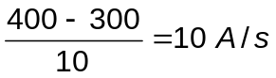  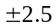value is accepted  Initial rate when [NaOH] = 0.400 mol dm⁻³  = 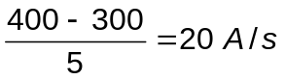  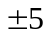value is accepted  For initial rates values that are outside the range, marks will not be given. However order of reaction can still be awarded.  When [NaOH] doubles, keeping [Y²⁻] constant, the rate also doubles. This implies that the order with respect to NaOH is 1.
 |  | (ii) | From Graph when [NaOH] = 0.200 mol dm⁻³  (show 2 sets of dotted lines to find half life)  The half-life of reaction is approximately constant at 25 sec, hence order of reaction with respect to Y²⁻ is 1  OR  From Graph when [NaOH] = 0.400 mol dm⁻³  (show 2 sets of dotted lines to find half life)  The half-life of reaction is approximately constant at 12.5 sec, hence order of reaction with respect to Y²⁻ is 1
 |  | (iii) | Rate = k [Y²⁻] [NaOH]
 | (b) | (i) | 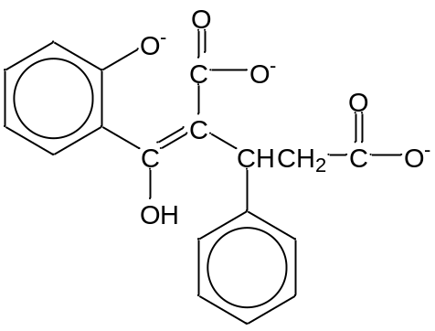
 |  | (ii) | 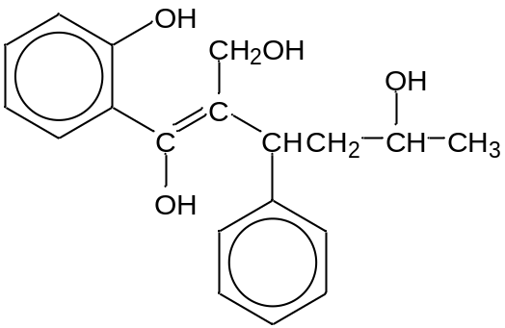
 | (c) | 2-aminophenol is less soluble in water due to the presence of intramolecular hydrogen bonding, making the OH and NH₂ group less available for hydrogen bonding with water molecules OR less extensive hydrogen bonding.
 | (d) | In the complex [Co(NH₃)₆]³⁺, the N atom in NH₃ is dative-bonded to Co³⁺ ion. Hence, there are 4 bond pairs and zero lone pairs on N atom.  Penalise if student writes about bp and lp on Co³⁺ ion.  To minimize repulsion, electron pairs are directed to the 4 corners of a tetrahedron, hence bond angle is about 109.5 º (110 º). In an isolated ammonia molecule, there are 3 bond pairs and 1 lone pair on N atom. Since lone pair-bond pair repulsion is larger than bond pair-bond pair repulsion, the bond angle is compressed to 107 º.

6 | (a) | (i) | Cathode: 2H₂O(l) + 2e → H₂(g) + 2OH⁻(aq)
 |  | (ii) | Z is ethane .  From the data, R₁ = R₂ = CH₃, hence the dimer is CH₃CH₃.
 |  | (iii) | Anode: 2 CH₃COO⁻ (aq) → CH₃CH₃ (g) + 2 CO₂ (g) + 2e
 |  | (iv) | 1 N m⁻² = 1 Pa  PV = nRT  (9.0 x 10⁴)(2.0 x 10⁻³) = 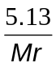 (8.31)(300)  M_{r} = 71.1 (1dp)  Since the gas is diatomic, the Ar of the atom = 71.1 2 = 35.5  Hence the gas is most likely to be chlorine, Cl₂
 | (b) | (i) | By Le Chatelier’s Principle, the equilibrium position will shift to the right to favour the endothermic reaction, by absorbing additional heat.
 |  | (ii) | To increase the pressure, the equilibrium position will shift to the right which results in more gaseous molecules.
 | (c) | Reagents: Aqueous Br₂ / Liquid Br₂  Conditions: Room temperature in the dark  Observations:  For phenylethene: Orange aqueous Br₂ / reddish brown Br₂ decolourised.  For 1,2-dichloroethane: Orange aqueous Br₂ / reddish brown Br₂ remains.  OR  Reagents: KMnO₄  Conditions: dilute H₂SO₄, heat  Observations:  For phenylethene: Purple KMnO₄ decolourised. Effervescence observed AND gas evolved forms white ppt with Ca(OH)₂ . White ppt of benzoic acid seen.  For 1,2-dichloroethane: Purple KMnO₄ remains.  OR  Reagents, conditions:  - Aq NaOH  - followed by excess dilute HNO₃  - AgNO₃(aq)  Observations:  For phenylethene: No white ppt formed.  For 1,2-dichloroethane: White ppt of AgCl formed.

